Dinis Schemann, Klavier
(www.dinis-schemann.eu)

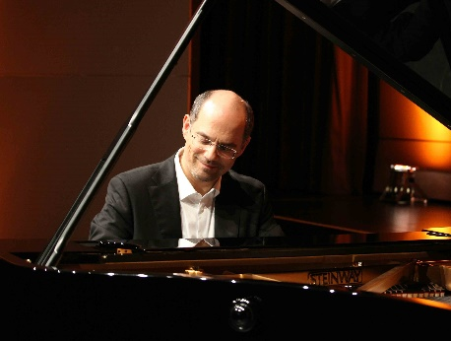
Dinis Schemann was born in the university town of Coimbra in Portugal and spent his childhood alternately in Lisbon and near Porto on the family estate. It was there where he started to play the piano already as a four-year-old. When he was 10 years old, the family moved to Germany.
As a teenager, Dinis Schemann studied with Prof. Günter Louegk, later with Prof. Alfons Kontarsky and Prof. Eckart Besch. He is thus in the tradition of the pianists Eduard Erdmann and Walter Gieseking.
Already at the age of 12, Dinis Schemann gave his first complete piano recital as a soloist. This concert was the starting signal for his career as a soloist and chamber musician; a career that today spans well over 1000 concerts.
He has been invited to many international music centers and festivals (Berliner Philharmonie, Rudolfinum Prague, Schleswig-Holstein Music Festival and many more).
His musical oeuvre is documented by recordings, which include coproductions with Bayerischer Rundfunk, Südwestrundfunk or Deutschlandradio.
He and his wife Susanne share a long-term musical collaboration as a piano duo.
Dinis Schemann also works as artistic director of several extremely successful concert series all over Germany. Together with his wife Susanne and the organizers on the respective sites he created twelve concert series.
He has accepted invitations to competitions only once, as a juror of the International ARD Competition in the piano duo division.
Dinis Schemann lives with his wife Susanne in the south of Germany and travels from there to various countries and cultures to perform at classical festivals and concert series.

